Exam 2024
Problem 1
Each player has expected utility(when they observe the crime) when cosidering both player playing a mixed strategy with probability of calling the police being p and q respectiely
$$u_{1}\left(p\right)=p·\frac{2}{3}+\left(1-p\right)·π·q=π·q+p·(\frac{2}{3}-π·q)$$
$$u_{2}\left(q\right)=q·\frac{2}{3}+\left(1-q\right)·π·p=p·π+q·(\frac{2}{3}-π·p)$$

What are each players best responses?
Lest first look at cases with $π=1,π=0$
$π=1$:
2 EQ in $p=0,q=1$
And in $q=1,p=0$
Look at BR method
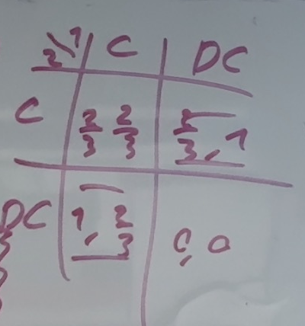
$π=0$:
Then each player is simply choosing between 2/3 and 0 meaning $p=1,q=1$
And a unique EQ in $(C,C)$

For $π<\frac{2}{3}$ we see that
$$\frac{du_{1}}{dp}=\left(\frac{2}{3}-π·q\right)>0$$
$$\frac{du_{2}}{dq}=\left(\frac{2}{3}-π·p\right)>0$$
Meaning that both players have positive expected utility in increasing their probability of playing Call
Meaning that they will both prefer to play call giving a EQ in $p=1,q=1$or $(C,C)$

Now for $π∈[\frac{2}{3},1)$ we set up best responses and check the diagram

Player 1
Maximize p if $\frac{2}{3}>π·q$
Minimize p if $\frac{2}{3}<π·q$
Indifferent if $π·q=\frac{2}{3}$
Giving best responses
$$BR_{1}\left(q\right)=\left\{\begin{aligned}1 for q<\frac{2}{π3} \\ \left[0,1\right]for q=\frac{2}{3π} \\ 0 for q>\frac{2}{3π}\end{aligned}\right.$$
By symmerty we get
$$BR_{2}\left(p\right)=\left\{\begin{aligned}1 for π·p<\frac{2}{3} \\ \left[0,1\right]for π·p=\frac{2}{3} \\ 0 for π·p>\frac{2}{3}\end{aligned}\right.$$
We draw the best response diagram and see that we will always have 3 EQ $for π∈[\frac{2}{3},1)$
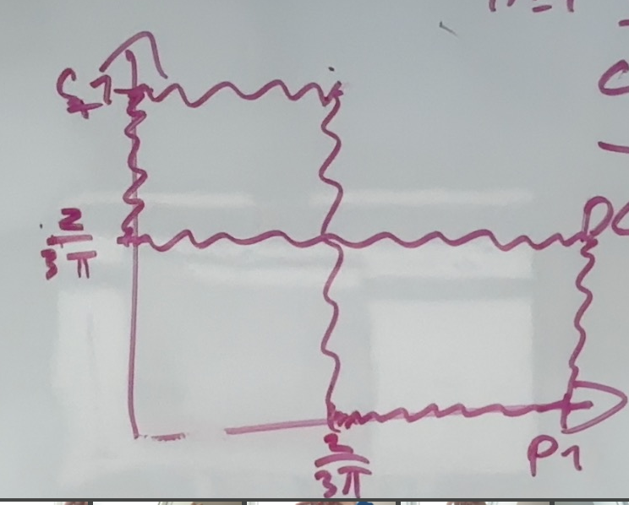

2 in the seperating EQ $\left(C,DC\right)\left(DC,C\right)$
And 1 in mixed strategies
With
$$p^{⋆}=q^{⋆}=\frac{2}{3π}≤1$$
Since $\frac{2}{3}≤π$

Problem 2
A)
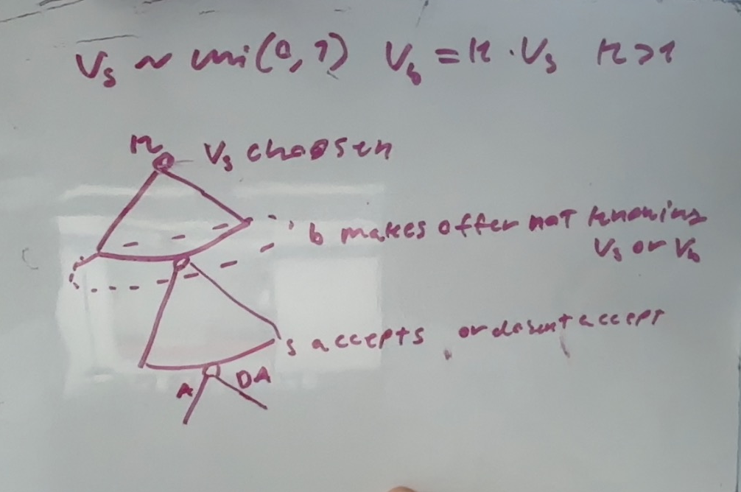

first we notice that S accepts the offer if and only if $p≥v_{s}$ B then gets expected utility
Uniform distribution gives
$$f\left(v\right)=1 for v∈[0,1]$$
Giving expectation
$$E\left[kv_{s} | v_{s}≤p\right]=\int_{0}^{p}{k·v dv}=\frac{k·p^{2}}{2}=0,5·k·p^{2}$$
Maximise expected utility
$$E\left[U\right]=E\left[kv_{s} | v_{s}≤p\right]-p=\frac{k}{2}·p^{2}-p$$
$$\frac{∂E\left[U\right]}{∂p}=k·p-1=0⇔we see that this is a minimum so noo good$$
So corner solution is best nothing over 1 can be viable since S always accepts for $p=1$
$$p=0⇒E\left[U\right]=0$$
$$p=1⇒E\left[U\right]=\frac{k}{2}-1$$
B) when k<2
Wee see that the best corner solution is p=0
meaning we have PBE in
$$(p=0,accept if p≥v_{s}\left(which it never is on path\right))$$
Well almost surely

C) when k>2
we see that $p=1$ is prefered for B
and that S wil always accept if $v_{s}≤p$ which it always is
giving PBE in $(p=1,Accept if v_{s}≤p)$

Problem 3
Here the notation specifies $(move by type winning , move by type nonwinning)$
I check seperating first
$(s=1,s=2)$:
D plays $A\left|s=1,R\right|s=2$
But then $P^{non}$ prefers to deviate $s=1$
Getting $1>0$ utiliy
Thus not an EQ

$\left(s=2,s=1\right)$:
D plays $R\left|s=1,A\right|s=2$
But then $P^{win}$ prefers to deviate to $s=2$ getting $2>-1$ utility
Thus not an EQ

Then pooling:
$\left(s=2,s=2\right)$:
On path D prefers:
$$u_{D}\left(A|s=2\right)=-2$$
$$u_{D}\left(R|s=2\right)=\frac{1}{3}·-4=-\left(\frac{4}{3}\right)≈-1,3333333$$
$$u_{D}\left(R|s=2\right)>u_{D}\left(A|s=2\right)$$
Thus D prefers to play $R|s=2$
We note that P will never deviate if $D$ plays $R|s=1$ and always deviate if D plays $A|s=1$
For this to be true we need
$$u_{D}\left(R | s=1\right)>u_{D}\left(A | s=1\right)$$
$$u_{D}\left(R | s=1\right)=-4·μ_{1}+\left(1-μ_{1}\right)·0=-\left(4·μ_{1}\right)$$
$$u_{D}\left(A | s=1\right)=-1$$
$$-\left(4·μ_{1}\right)≥-1$$
$⇕$
$$μ_{1}≤\frac{1}{4}$$
Thus we have an EQ in
$$\{\left(s=2,s=2\right)\left(R\left|s=1,R\right|s=1\right) for μ_{1}≤\frac{1}{4}\}$$
$(s=1,s=1)$:
On path D prefers:
$$u_{D}\left(A|s=1\right)=-1$$
$$u_{D}\left(R|s=1\right)=\frac{1}{3}·-4=-\left(\frac{4}{3}\right)≈-1,3333333$$
$$u_{D}\left(R|s=1\right)<u_{D}\left(A|s=1\right)$$
Then D prefers to play A
$P^{win}$ always prefers to deviate since $1<2<3$
Meaning this can never be an eq

Then we know that the only posible eq is pooling on $s=2$
$$\{\left(s=2,s=2\right)\left(R\left|s=1,R\right|s=1\right) for μ_{1}≤\frac{1}{4}\}$$

Problem 4
$$c_{H}>c_{L}$$
$$π_{H}>π_{L}$$
$$λ_{H}>λ_{L}$$

$$Π\left(π,w\right)=π-w$$
$$u\left(w,e\right)=\sqrt{w}-c_{e}$$
$$λ_{H}>λ_{L}·\frac{c_{H}}{c_{L}}$$
- In the first best solution in exactly these settings (concave utility function in compensation and risk neutral firm) that the risk averse party has fixed wage and binding PC
Giving us the 2 solutions
Implement high
$$\sqrt{w}-c_{H}=0⇔w=c_{H}^{2}$$

Implement low effort:
$$\sqrt{w}-c_{L}=0⇔w=c_{L}^{2}$$

Problem 5

